**Changing visuals**

In this exercise, you are going to change and format visuals. First, you will turn the donut chart into a tree map to get a better understanding of the product categories. Then, you will change the simple card visual to a multi-row card so that it is possible to closely track the actual, forecasted, and budgeted amounts.

Begin by closing any open reports, downloading and opening the Changing_Visuals.pbix from Canvas into your local drive.

* Change the donut chart to a tree map. You can do this by clicking once the donut visual and then select Treemap option from the Visualizations pane.

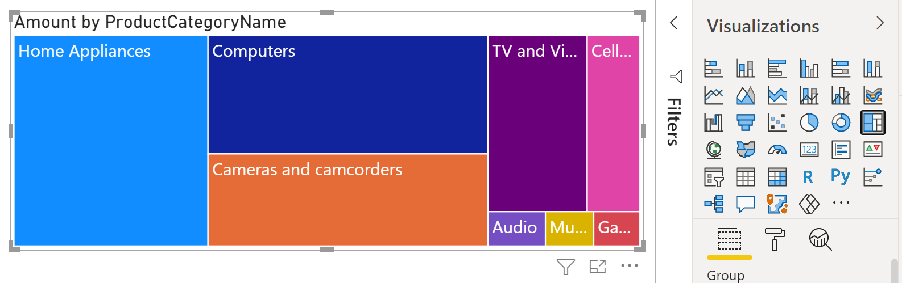



* Go into the formatting settings and set the title of the chart to Product Category Amount with a size of 16.

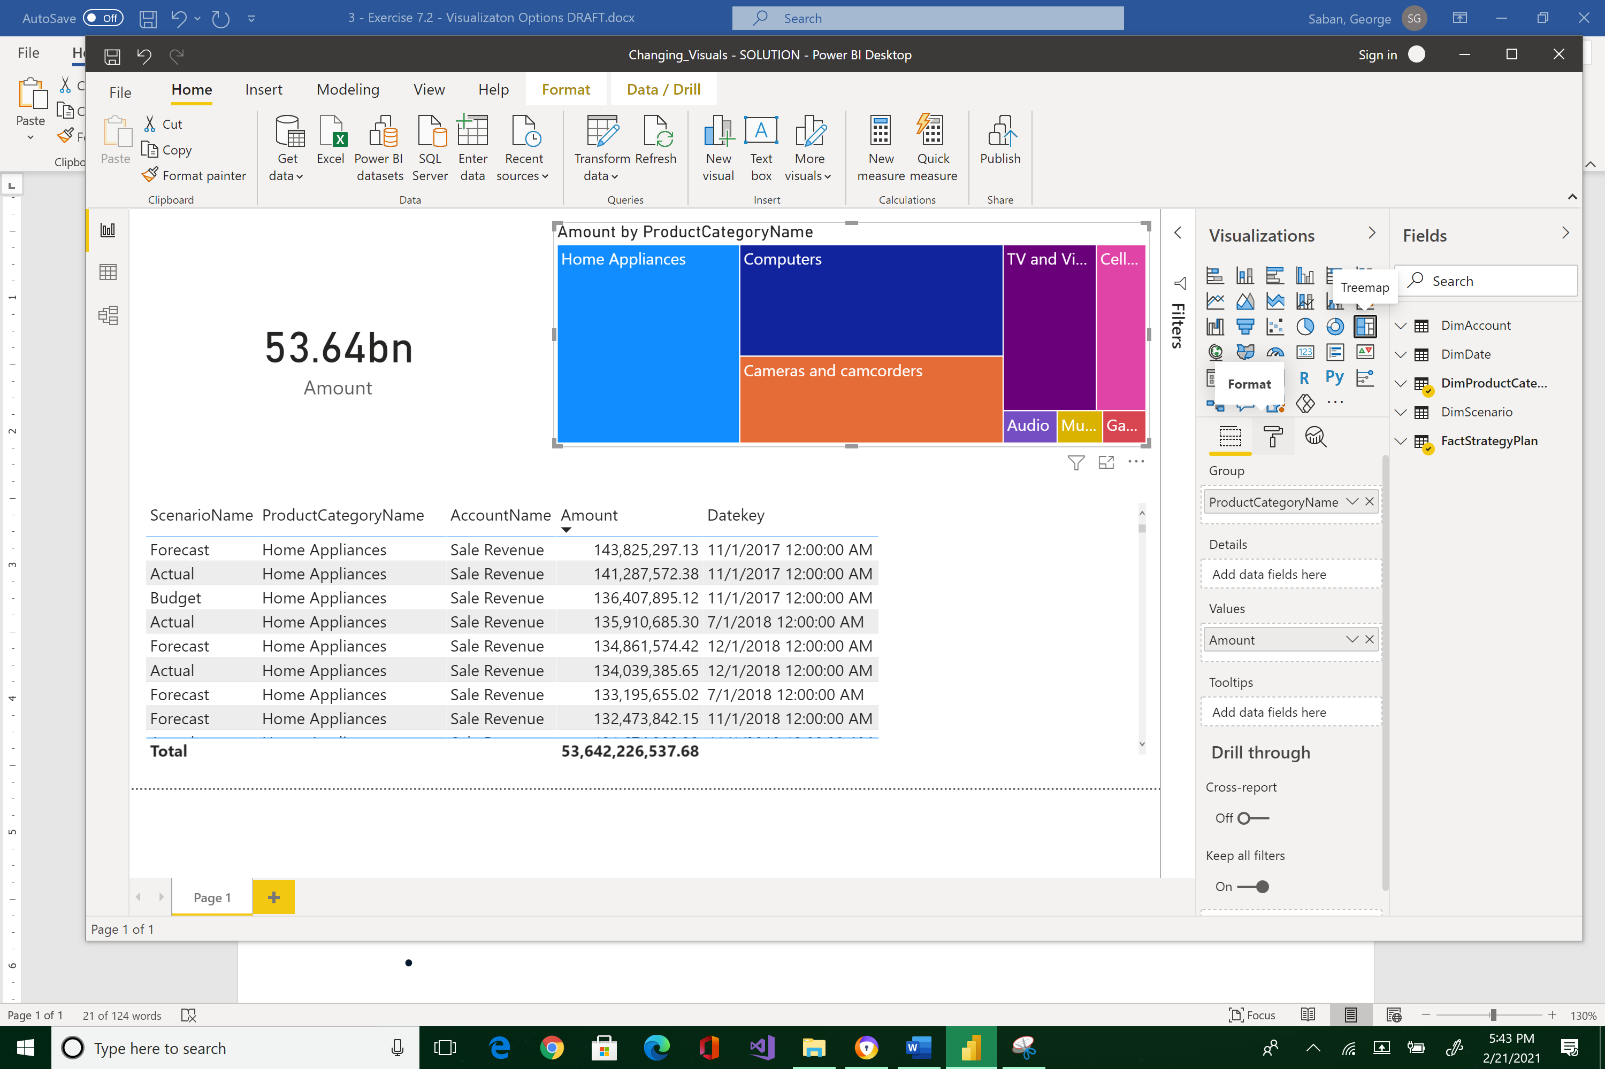



Expand Title option of the Format widget and change the Title text textbox to “Product Category Amount”. Also, change Text size to 16.

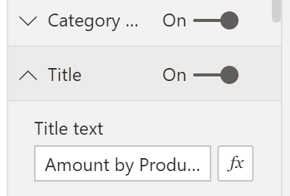



You should see the title of the Treemap visual automatically updated by now.

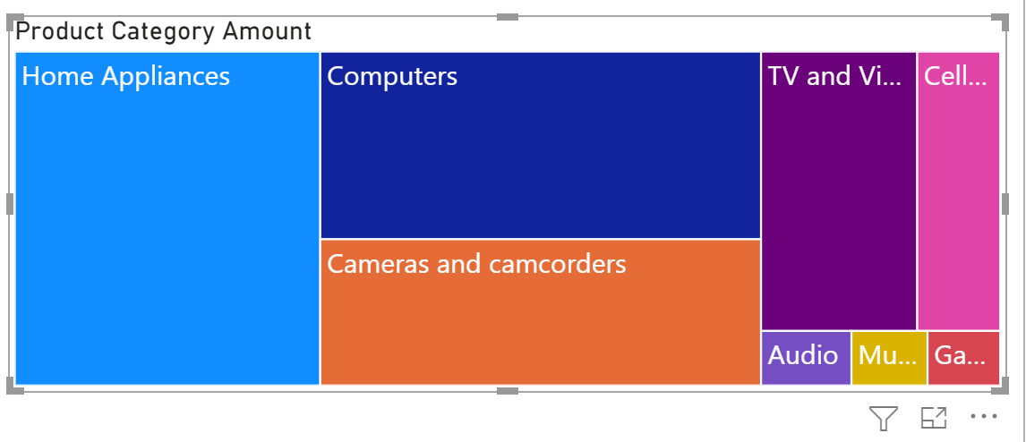



* Change the card in the top left-hand corner to a multi-row card. Select the card widget, and then click the Multi-row card.

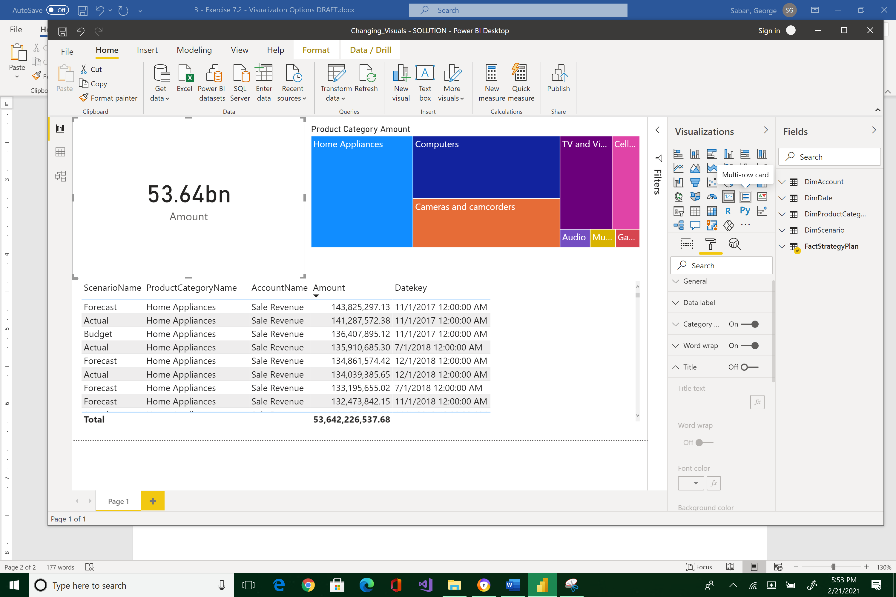



* Add the scenario name to the multi-row card.

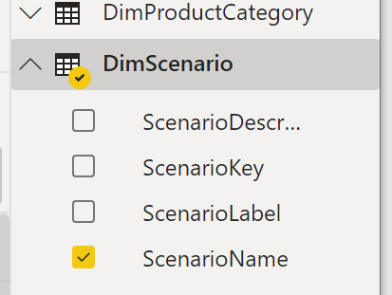 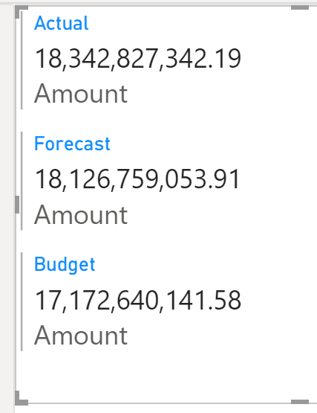



* **What is the total forecasted sales amount (answer format: $#.###B)?**

|  |
| --- |
| $18.126B |

Save your work first, often, and regularly.

**More next page --->**

Please reposition your Report so that it would look like the image below. Take a snapshot using Window's Snipping Tool. Make sure the encircled items are included. Place your image at the end of this document (after the example below) and submit this completed artifact to Canvas in Word format.  Congratulations for reaching this far in the course--you are doing great!

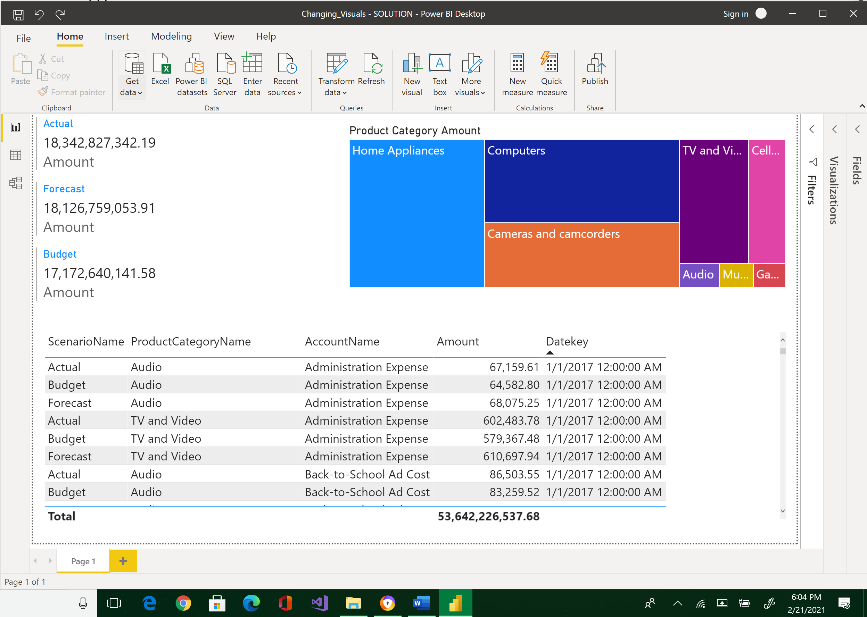



|  |
| --- |
| Please paste here your final image. |